**OUTREACH SCHOOLS EXAMINATION BOARD**

**BEGINNING OF TERM III EXAMINATION 2023**

**TOP CLASS: (5 – 6 YEARS)**

**LEARNING AREA 2: LANGUAGE DEVELOPMENT I**

**My name is: ……………………………………………………………….**

**My School is: …………………………………….………………………..**

**I am in: ………………………………..…………………………….…………………..**

1. **Write the words in plural.**

boy _______________ flower ___________

table ______________ table ___________

house _____________ ball ____________

1. **Complete the sentences using “a” or “an”.**

I have ______________ orange.

I have ____________ bag.

Sarah is eating _____________ apple.

That is ______________ umbrella.

We have _________________ big house.

1. **Write these words in small letters.**

LEAF _____________________

BOY _____________________

STAR _____________________

FISH _____________________

KEY _______________________

1. **Write the letter between.**

a ____ c h ___ j m ____o

q ___s w ____ y d ____f

1. **Name these pictures.**

__________________



__________________

_________________

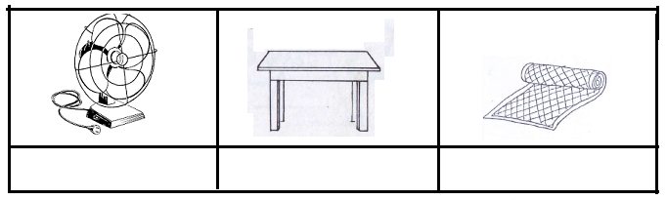

________________

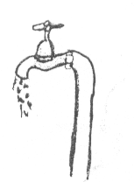

_________________

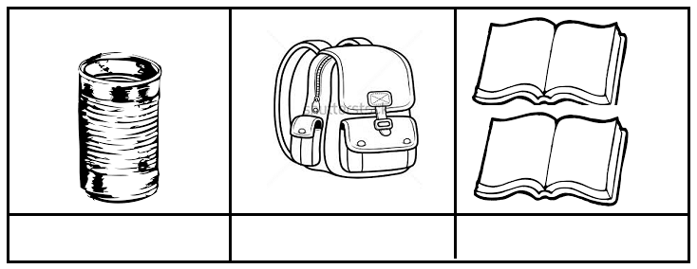

___________________

__________________

1. **Match to the prepositions.**

over

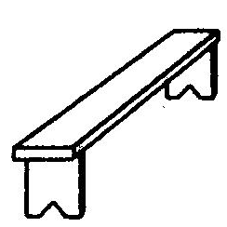

near

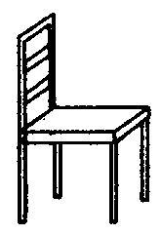

 under

on

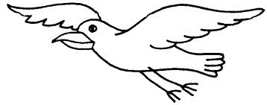

in

**End**